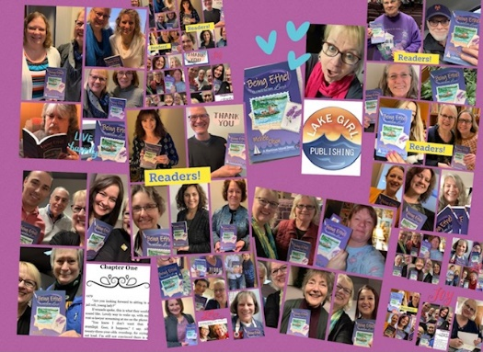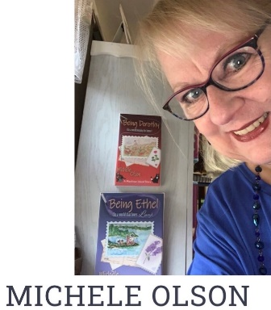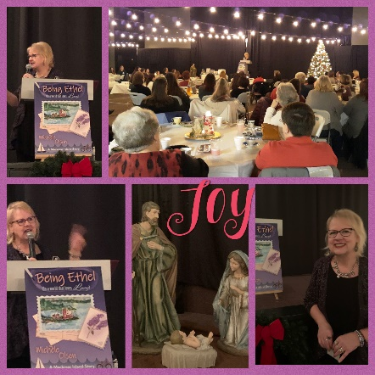
Michele is a seasoned writer, broadcaster, voice pro, speaker, sketchdoodler, artist, and author with over 40 years of experience. With over 100 blog articles as a health writer, and the voice for countless commercials, videos, and voice-over projects, her focus is author and speaker based on Mackinac Island stories filled with mystery, romance, friendship, and faith and the joy of creativity for everyone.
The author of Being Ethel (In a world that loves Lucy) and Being Dorothy (In a world longing for home) and Being Alice (In a world lost in the looking glass) she writes to Fuel Faith with Fiction as the main goal of her creative imprint-Lake Girl Publishing and LakeGirlPublishing.com.
Her message involves the common experience of being overlooked and playing the role of “Ethel” when the world treasures “Lucy.” She shares the truth of being seen, valued, unique, and important for every person.
Being Ethel (In a world that loves Lucy) is a 5-star reviewed novel in eBook, paperback, and audiobook which has hit the top 100 on Amazon.
Along with her debut novel, her stand-alone sequels- Being Dorothy (In a world longing for home) and Being Alice (In a world lost in the looking glass) 5-star reviewed novels, well-received in bookstores, libraries, and book clubs in eBook and paperback.
A wife, mother to two adult children, Gee Gee to two grandchildren, Michele enjoys connecting with in-person, through social media, and at speaking, teaching, and sketchdoodling events.
For interviews, speaking events, book signings, professional sketchdoodling at events or taught to groups, contact Michele at:
info@lakegirlpublishing.com www.lakegirlpublishing.com
Visit her website to learn more about her books, hear her voice over work, sketchdoodling for companies, art, audiobook examples and more!

